Terraform Output:

Cmd 1: ssh-keygen -f oregon-region-key-pair

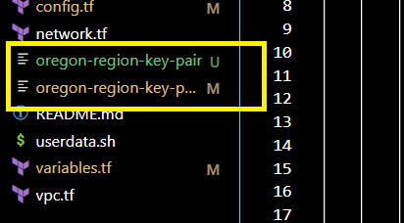

Cmd 2: terraform init

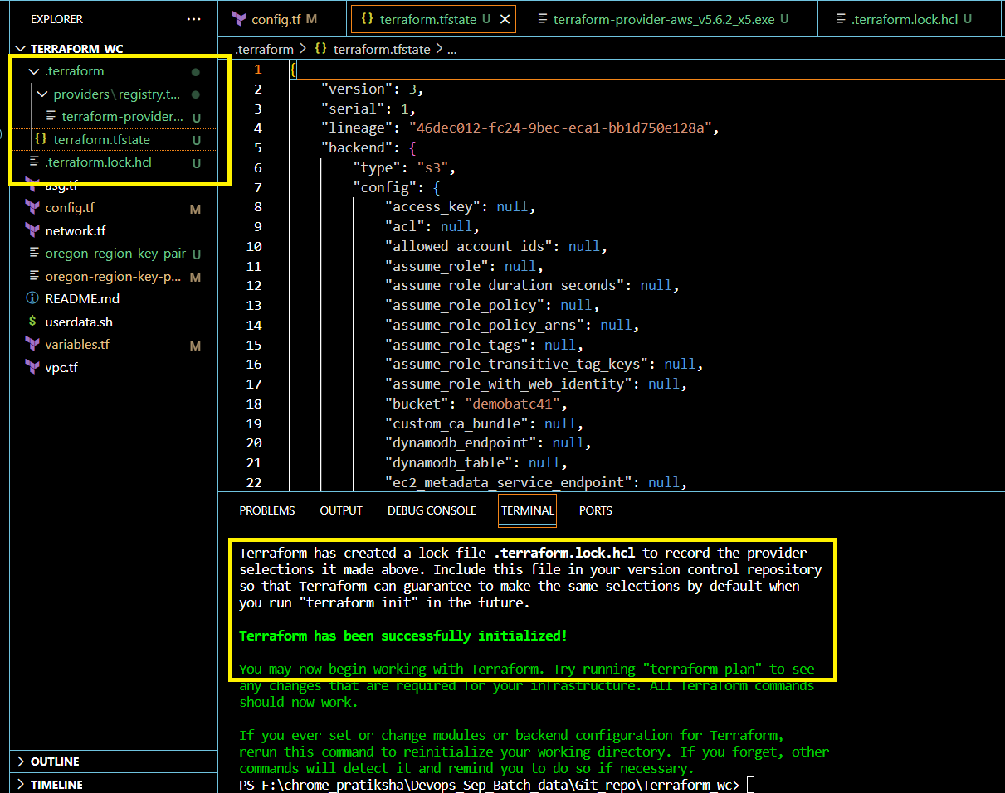

\

Cmd 3: terraform plan -out "file.plan"

---------Output got on cmd window

Terraform used the selected providers to generate the following execution plan. Resource actions are indicated with the following symbols:

+ create

Terraform will perform the following actions:

# aws_autoscaling_group.dev-autoscaling-group will be created

+ resource "aws_autoscaling_group" "dev-autoscaling-group" {

+ arn = (known after apply)

+ availability_zones = (known after apply)

+ default_cooldown = (known after apply)

+ desired_capacity = (known after apply)

+ force_delete = false

+ force_delete_warm_pool = false

+ health_check_grace_period = 300

+ health_check_type = (known after apply)

+ id = (known after apply)

+ launch_configuration = "dev-launch-config"

+ load_balancers = (known after apply)

+ max_size = 1

+ metrics_granularity = "1Minute"

+ min_size = 1

+ name = "dev-asg"

+ name_prefix = (known after apply)

+ predicted_capacity = (known after apply)

+ protect_from_scale_in = false

+ service_linked_role_arn = (known after apply)

+ target_group_arns = (known after apply)

+ vpc_zone_identifier = (known after apply)

+ wait_for_capacity_timeout = "10m"

+ warm_pool_size = (known after apply)

+ tag {

+ key = "Name"

+ propagate_at_launch = true

+ value = "dev-test"

}

}

# aws_internet_gateway.dev-igw will be created

+ resource "aws_internet_gateway" "dev-igw" {

+ arn = (known after apply)

+ id = (known after apply)

+ owner_id = (known after apply)

+ tags = {

+ "Name" = "dev-igw"

}

+ tags_all = {

+ "Name" = "dev-igw"

}

+ vpc_id = (known after apply)

}

# aws_key_pair.oregon-region-key-pair will be created

+ resource "aws_key_pair" "oregon-region-key-pair" {

+ arn = (known after apply)

+ fingerprint = (known after apply)

+ id = (known after apply)

+ key_name = "oregon-region-key-pair"

+ key_name_prefix = (known after apply)

+ key_pair_id = (known after apply)

+ key_type = (known after apply)

+ public_key = "ssh-rsa  admin@DESKTOP-3R484SM"

+ tags_all = (known after apply)

}

# aws_launch_configuration.dev-launch-config will be created

+ resource "aws_launch_configuration" "dev-launch-config" {

+ arn = (known after apply)

+ associate_public_ip_address = true

+ ebs_optimized = (known after apply)

+ enable_monitoring = true

+ id = (known after apply)

+ image_id = "ami-0d593311db5abb72b"

+ instance_type = "t2.micro"

+ key_name = (known after apply)

+ name = "dev-launch-config"

+ name_prefix = (known after apply)

+ security_groups = (known after apply)

+ user_data = "f39b9fb514e7a28be22470e95646b1d9ba99c867"

}

# aws_route_table.dev-public-crt will be created

+ resource "aws_route_table" "dev-public-crt" {

+ arn = (known after apply)

+ id = (known after apply)

+ owner_id = (known after apply)

+ propagating_vgws = (known after apply)

+ route = [

+ {

+ carrier_gateway_id = ""

+ cidr_block = "0.0.0.0/0"

+ core_network_arn = ""

+ destination_prefix_list_id = ""

+ egress_only_gateway_id = ""

+ gateway_id = (known after apply)

+ ipv6_cidr_block = ""

+ local_gateway_id = ""

+ nat_gateway_id = ""

+ network_interface_id = ""

+ transit_gateway_id = ""

+ vpc_endpoint_id = ""

+ vpc_peering_connection_id = ""

},

]

+ tags = {

+ "Name" = "dev-public-crt"

}

+ tags_all = {

+ "Name" = "dev-public-crt"

}

+ vpc_id = (known after apply)

}

# aws_route_table_association.dev-crta-public-subnet-1 will be created

+ resource "aws_route_table_association" "dev-crta-public-subnet-1" {

+ id = (known after apply)

+ route_table_id = (known after apply)

+ subnet_id = (known after apply)

}

# aws_security_group.ssh-allowed will be created

+ resource "aws_security_group" "ssh-allowed" {

+ arn = (known after apply)

+ description = "Managed by Terraform"

+ egress = [

+ {

+ cidr_blocks = [

+ "0.0.0.0/0",

]

+ description = ""

+ from_port = 0

+ ipv6_cidr_blocks = []

+ prefix_list_ids = []

+ protocol = "-1"

+ security_groups = []

+ self = false

+ to_port = 0

},

]

+ id = (known after apply)

+ ingress = [

+ {

+ cidr_blocks = [

+ "0.0.0.0/0",

]

+ description = ""

+ from_port = 22

+ ipv6_cidr_blocks = []

+ prefix_list_ids = []

+ protocol = "tcp"

+ security_groups = []

+ self = false

+ to_port = 22

},

+ {

+ cidr_blocks = [

+ "0.0.0.0/0",

]

+ description = ""

+ from_port = 80

+ ipv6_cidr_blocks = []

+ prefix_list_ids = []

+ protocol = "tcp"

+ security_groups = []

+ self = false

+ to_port = 80

},

]

+ name = (known after apply)

+ name_prefix = (known after apply)

+ owner_id = (known after apply)

+ revoke_rules_on_delete = false

+ tags = {

+ "Name" = "ssh-allowed"

}

+ tags_all = {

+ "Name" = "ssh-allowed"

}

+ vpc_id = (known after apply)

}

# aws_subnet.dev-subnet-public-1 will be created

+ resource "aws_subnet" "dev-subnet-public-1" {

+ arn = (known after apply)

+ assign_ipv6_address_on_creation = false

+ availability_zone = "us-west-2a"

+ availability_zone_id = (known after apply)

+ cidr_block = "10.0.1.0/24"

+ enable_dns64 = false

+ enable_resource_name_dns_a_record_on_launch = false

+ enable_resource_name_dns_aaaa_record_on_launch = false

+ id = (known after apply)

+ ipv6_cidr_block_association_id = (known after apply)

+ ipv6_native = false

+ map_public_ip_on_launch = true

+ owner_id = (known after apply)

+ private_dns_hostname_type_on_launch = (known after apply)

+ tags = {

+ "Name" = "dev-subnet-public-1"

}

+ tags_all = {

+ "Name" = "dev-subnet-public-1"

}

+ vpc_id = (known after apply)

}

# aws_vpc.dev-vpc will be created

+ resource "aws_vpc" "dev-vpc" {

+ arn = (known after apply)

+ cidr_block = "10.0.0.0/16"

+ default_network_acl_id = (known after apply)

+ default_route_table_id = (known after apply)

+ default_security_group_id = (known after apply)

+ dhcp_options_id = (known after apply)

+ enable_dns_hostnames = true

+ enable_dns_support = true

+ enable_network_address_usage_metrics = (known after apply)

+ id = (known after apply)

+ instance_tenancy = "default"

+ ipv6_association_id = (known after apply)

+ ipv6_cidr_block = (known after apply)

+ ipv6_cidr_block_network_border_group = (known after apply)

+ main_route_table_id = (known after apply)

+ owner_id = (known after apply)

+ tags = {

+ "Name" = "dev-vpc"

}

+ tags_all = {

+ "Name" = "dev-vpc"

}

}

Plan: 9 to add, 0 to change, 0 to destroy.

────────────────────────────────────────────────────────────────────────────────────────────────────────────────────────────────────────────────────────────────────────────

Saved the plan to: file.plan

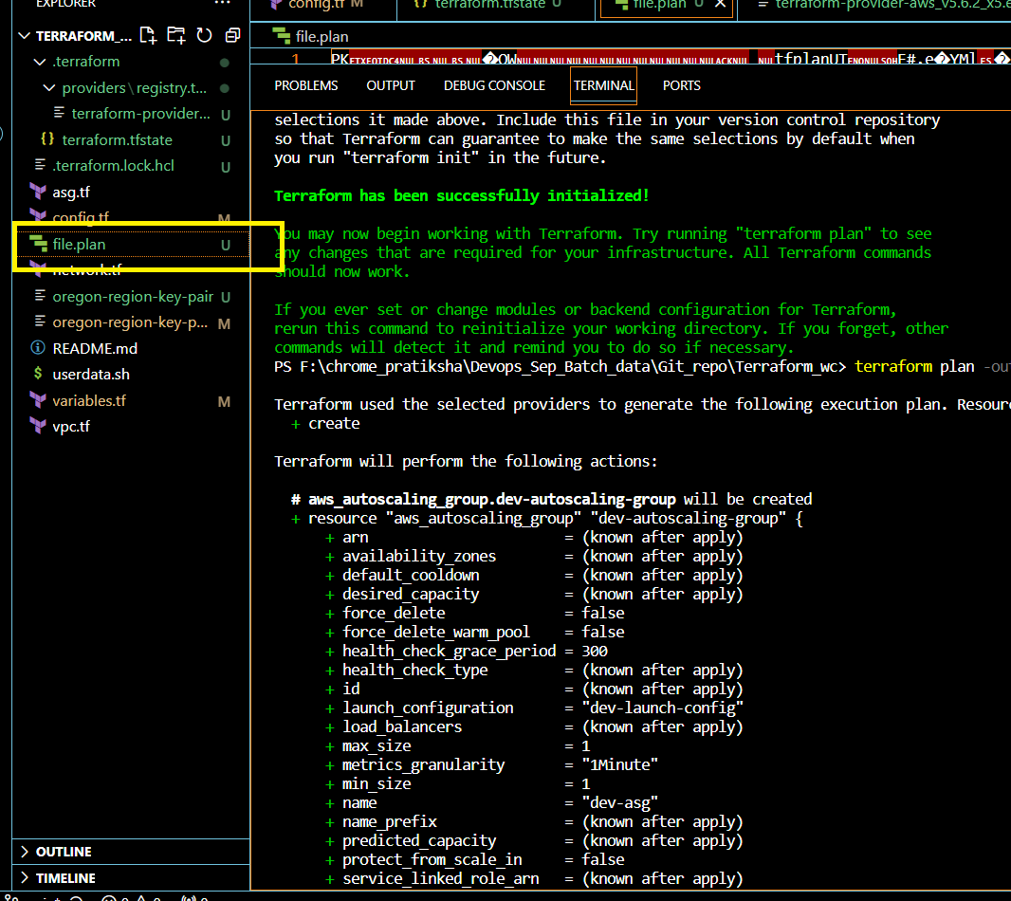

Cmd 4: terraform apply

{Note: As e just passed apply cmd it had first created plan file and then applied it if you want just apply created plan file then use: terraform apply “file1.plan” }

Terraform used the selected providers to generate the following execution plan. Resource actions are indicated with the following symbols:

+ create

Terraform will perform the following actions:

# aws_autoscaling_group.dev-autoscaling-group will be created

+ resource "aws_autoscaling_group" "dev-autoscaling-group" {

+ arn = (known after apply)

+ availability_zones = (known after apply)

+ default_cooldown = (known after apply)

+ desired_capacity = (known after apply)

+ force_delete = false

+ force_delete_warm_pool = false

+ health_check_grace_period = 300

+ health_check_type = (known after apply)

+ id = (known after apply)

+ launch_configuration = "dev-launch-config"

+ load_balancers = (known after apply)

+ max_size = 1

+ metrics_granularity = "1Minute"

+ min_size = 1

+ name = "dev-asg"

+ name_prefix = (known after apply)

+ predicted_capacity = (known after apply)

+ protect_from_scale_in = false

+ service_linked_role_arn = (known after apply)

+ target_group_arns = (known after apply)

+ vpc_zone_identifier = (known after apply)

+ wait_for_capacity_timeout = "10m"

+ warm_pool_size = (known after apply)

+ tag {

+ key = "Name"

+ propagate_at_launch = true

+ value = "dev-test"

}

}

# aws_internet_gateway.dev-igw will be created

+ resource "aws_internet_gateway" "dev-igw" {

+ arn = (known after apply)

+ id = (known after apply)

+ owner_id = (known after apply)

+ tags = {

+ "Name" = "dev-igw"

}

+ tags_all = {

+ "Name" = "dev-igw"

}

+ vpc_id = (known after apply)

}

# aws_key_pair.oregon-region-key-pair will be created

+ resource "aws_key_pair" "oregon-region-key-pair" {

+ arn = (known after apply)

+ fingerprint = (known after apply)

+ id = (known after apply)

+ key_name = "oregon-region-key-pair"

+ key_name_prefix = (known after apply)

+ key_pair_id = (known after apply)

+ key_type = (known after apply)

+ public_key = "ssh-rsa  admin@DESKTOP-3R484SM"

+ tags_all = (known after apply)

}

# aws_launch_configuration.dev-launch-config will be created

+ resource "aws_launch_configuration" "dev-launch-config" {

+ arn = (known after apply)

+ associate_public_ip_address = true

+ ebs_optimized = (known after apply)

+ enable_monitoring = true

+ id = (known after apply)

+ image_id = "ami-0d593311db5abb72b"

+ instance_type = "t2.micro"

+ key_name = (known after apply)

+ name = "dev-launch-config"

+ name_prefix = (known after apply)

+ security_groups = (known after apply)

+ user_data = "f39b9fb514e7a28be22470e95646b1d9ba99c867"

}

# aws_route_table.dev-public-crt will be created

+ resource "aws_route_table" "dev-public-crt" {

+ arn = (known after apply)

+ id = (known after apply)

+ owner_id = (known after apply)

+ propagating_vgws = (known after apply)

+ route = [

+ {

+ carrier_gateway_id = ""

+ cidr_block = "0.0.0.0/0"

+ core_network_arn = ""

+ destination_prefix_list_id = ""

+ egress_only_gateway_id = ""

+ gateway_id = (known after apply)

+ ipv6_cidr_block = ""

+ local_gateway_id = ""

+ nat_gateway_id = ""

+ network_interface_id = ""

+ transit_gateway_id = ""

+ vpc_endpoint_id = ""

+ vpc_peering_connection_id = ""

},

]

+ tags = {

+ "Name" = "dev-public-crt"

}

+ tags_all = {

+ "Name" = "dev-public-crt"

}

+ vpc_id = (known after apply)

}

# aws_route_table_association.dev-crta-public-subnet-1 will be created

+ resource "aws_route_table_association" "dev-crta-public-subnet-1" {

+ id = (known after apply)

+ route_table_id = (known after apply)

+ subnet_id = (known after apply)

}

# aws_security_group.ssh-allowed will be created

+ resource "aws_security_group" "ssh-allowed" {

+ arn = (known after apply)

+ description = "Managed by Terraform"

+ egress = [

+ {

+ cidr_blocks = [

+ "0.0.0.0/0",

]

+ description = ""

+ from_port = 0

+ ipv6_cidr_blocks = []

+ prefix_list_ids = []

+ protocol = "-1"

+ security_groups = []

+ self = false

+ to_port = 0

},

]

+ id = (known after apply)

+ ingress = [

+ {

+ cidr_blocks = [

+ "0.0.0.0/0",

]

+ description = ""

+ from_port = 22

+ ipv6_cidr_blocks = []

+ prefix_list_ids = []

+ protocol = "tcp"

+ security_groups = []

+ self = false

+ to_port = 22

},

+ {

+ cidr_blocks = [

+ "0.0.0.0/0",

]

+ description = ""

+ from_port = 80

+ ipv6_cidr_blocks = []

+ prefix_list_ids = []

+ protocol = "tcp"

+ security_groups = []

+ self = false

+ to_port = 80

},

]

+ name = (known after apply)

+ name_prefix = (known after apply)

+ owner_id = (known after apply)

+ revoke_rules_on_delete = false

+ tags = {

+ "Name" = "ssh-allowed"

}

+ tags_all = {

+ "Name" = "ssh-allowed"

}

+ vpc_id = (known after apply)

}

# aws_subnet.dev-subnet-public-1 will be created

+ resource "aws_subnet" "dev-subnet-public-1" {

+ arn = (known after apply)

+ assign_ipv6_address_on_creation = false

+ availability_zone = "us-west-2a"

+ availability_zone_id = (known after apply)

+ cidr_block = "10.0.1.0/24"

+ enable_dns64 = false

+ enable_resource_name_dns_a_record_on_launch = false

+ enable_resource_name_dns_aaaa_record_on_launch = false

+ id = (known after apply)

+ ipv6_cidr_block_association_id = (known after apply)

+ ipv6_native = false

+ map_public_ip_on_launch = true

+ owner_id = (known after apply)

+ private_dns_hostname_type_on_launch = (known after apply)

+ tags = {

+ "Name" = "dev-subnet-public-1"

}

+ tags_all = {

+ "Name" = "dev-subnet-public-1"

}

+ vpc_id = (known after apply)

}

# aws_vpc.dev-vpc will be created

+ resource "aws_vpc" "dev-vpc" {

+ arn = (known after apply)

+ cidr_block = "10.0.0.0/16"

+ default_network_acl_id = (known after apply)

+ default_route_table_id = (known after apply)

+ default_security_group_id = (known after apply)

+ dhcp_options_id = (known after apply)

+ enable_dns_hostnames = true

+ enable_dns_support = true

+ enable_network_address_usage_metrics = (known after apply)

+ id = (known after apply)

+ instance_tenancy = "default"

+ ipv6_association_id = (known after apply)

+ ipv6_cidr_block = (known after apply)

+ ipv6_cidr_block_network_border_group = (known after apply)

+ main_route_table_id = (known after apply)

+ owner_id = (known after apply)

+ tags = {

+ "Name" = "dev-vpc"

}

+ tags_all = {

+ "Name" = "dev-vpc"

}

}

Plan: 9 to add, 0 to change, 0 to destroy.

Do you want to perform these actions?

Terraform will perform the actions described above.

Only 'yes' will be accepted to approve.

Enter a value: yes

aws_vpc.dev-vpc: Creating...

aws_key_pair.oregon-region-key-pair: Creating...

aws_key_pair.oregon-region-key-pair: Creation complete after 2s [id=oregon-region-key-pair]

aws_vpc.dev-vpc: Still creating... [10s elapsed]

aws_vpc.dev-vpc: Creation complete after 15s [id=vpc-03eaf9bbde4f1e8b3]

aws_internet_gateway.dev-igw: Creating...

aws_subnet.dev-subnet-public-1: Creating...

aws_security_group.ssh-allowed: Creating...

aws_internet_gateway.dev-igw: Creation complete after 2s [id=igw-0d4e51cf8d7197cea]

aws_route_table.dev-public-crt: Creating...

aws_route_table.dev-public-crt: Creation complete after 3s [id=rtb-0070d25b1f367b7ed]

aws_security_group.ssh-allowed: Creation complete after 6s [id=sg-008ab9c07c388b518]

aws_launch_configuration.dev-launch-config: Creating...

aws_launch_configuration.dev-launch-config: Creation complete after 2s [id=dev-launch-config]

aws_subnet.dev-subnet-public-1: Still creating... [10s elapsed]

aws_subnet.dev-subnet-public-1: Creation complete after 13s [id=subnet-0494d14e613cf2bb0]

aws_route_table_association.dev-crta-public-subnet-1: Creating...

aws_autoscaling_group.dev-autoscaling-group: Creating...

aws_route_table_association.dev-crta-public-subnet-1: Creation complete after 1s [id=rtbassoc-03ce78393acbf1397]

aws_autoscaling_group.dev-autoscaling-group: Still creating... [10s elapsed]

aws_autoscaling_group.dev-autoscaling-group: Still creating... [20s elapsed]

aws_autoscaling_group.dev-autoscaling-group: Still creating... [30s elapsed]

aws_autoscaling_group.dev-autoscaling-group: Still creating... [40s elapsed]

aws_autoscaling_group.dev-autoscaling-group: Creation complete after 44s [id=dev-asg]

Apply complete! Resources: 9 added, 0 changed, 0 destroyed.

1. Created EC2 instance

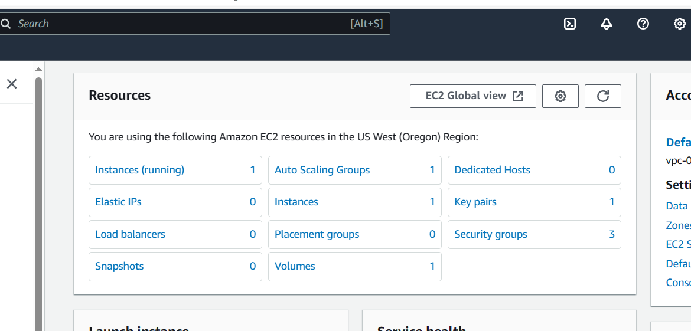

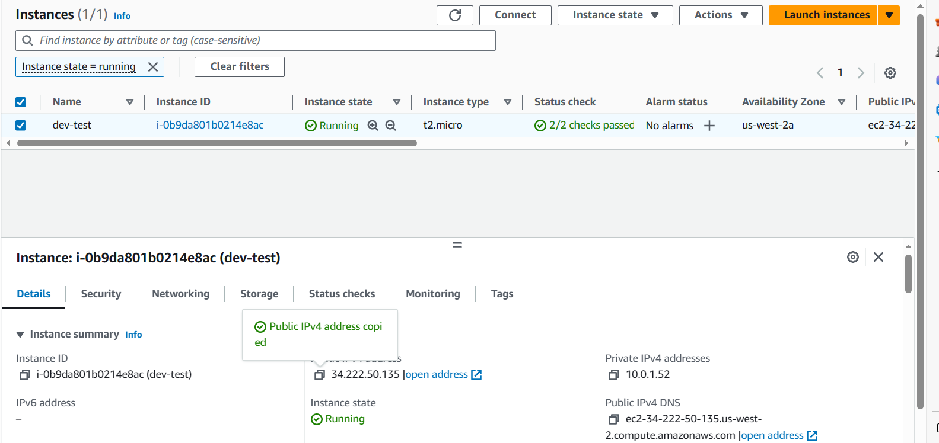

1. As http apache is also installed so working page with ip

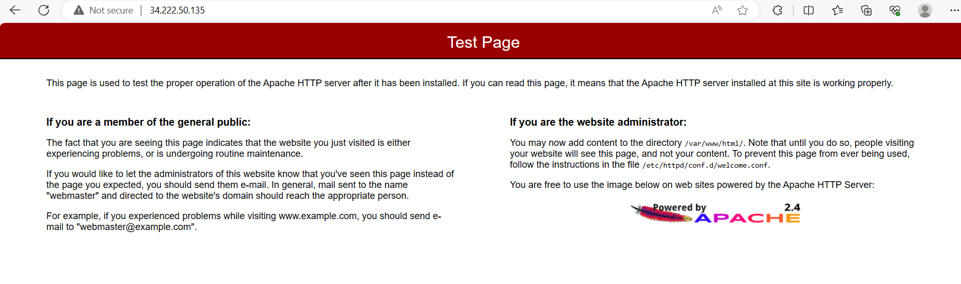

1. Created yes named state file in s3 bucket

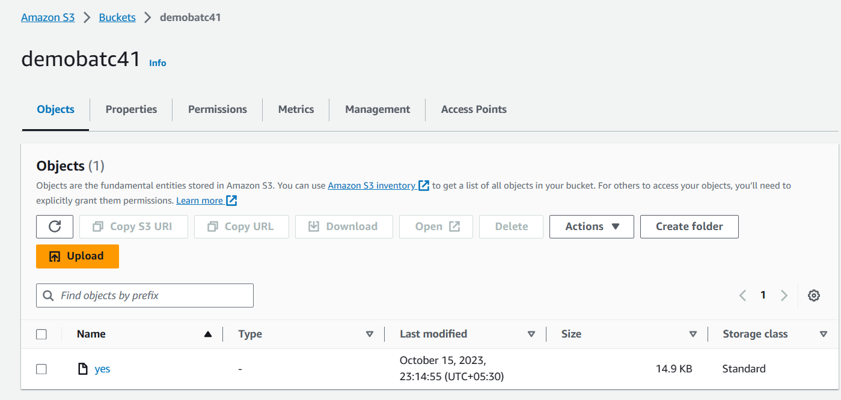

File :

